

**TV ONLINE SHOP PROJECT**

**Software Requirement Specification**

**Group 1**

– Hanoi, August 2022 –

**Table of Contents**

I. Overview 5

1. Introduction 5

2. System Functions 5

a. Screen Flow 5

b. Screen Details 7

c. User Authorization 8

d. Non-Screen Functions 8

3. Entity Relationship Diagram 9

II. Functional Requirements 10

1. Login and Sign up 10

a.Login 10

b. Login with Google Account 11

c. Sign up 11

2. Home 12

3. TV detail 12

4. User profile 13

5. Password 13

a. Change Password 13

b. Forgot Password 14

6. Manage Account 14

7. Edit Account 15

8. Add Staff Account 15

9. Delete staff account 15

10. Manage Reveue 16

11. Export order to Excel 16

12. Product manage 17

13. Add product 17

14. Edit Product 17

15. Delete Product 18

16. Search product 18

17. Manage order 19

18. Update order 19

19. Search order 19

20. Add to cart 20

21. Edit cart 20

22. Purchase 21

23. Tracking order 21

**RECORD OF CHANGES**

|  |  |  |  |
| --- | --- | --- | --- |
| Date | A* M, D | In charge | Change Description |
| 03/01 | M |  | Choose Topic Online TV Shop. |
| 09/01 | M |  | Create plan for single iteration and milestone, goal for single iteration. |
| 12/01 | M |  | Create Database |
| 18/01 | M |  | Fix Database |
| 03/02 | M |  | Fix Database |
| 03/02 | M |  | Create SRS Documentary |
| 07/02 | M |  | Find and create template |
| 08/02 | M |  | Learning Using git to push code |
| 10/02 | M |  | Code Login and logout feature |
| 13/02 | M |  | Code CRUD of user |
| 13/02 | M |  | Code UserProfile |
| 13/02 | M |  | Add document to SRS documentary |
| 17/02 | A |  | Code Home Page |
| 21/02 | A |  | Create SDS documentary |

# I. Overview

## 1. Introduction

Television Online Shop - SWP391's online TV sales system. In this system, users will easily find and buy televisions more easily. As for store owners, they will easily manage, sell TV and view sales statistics more easily.

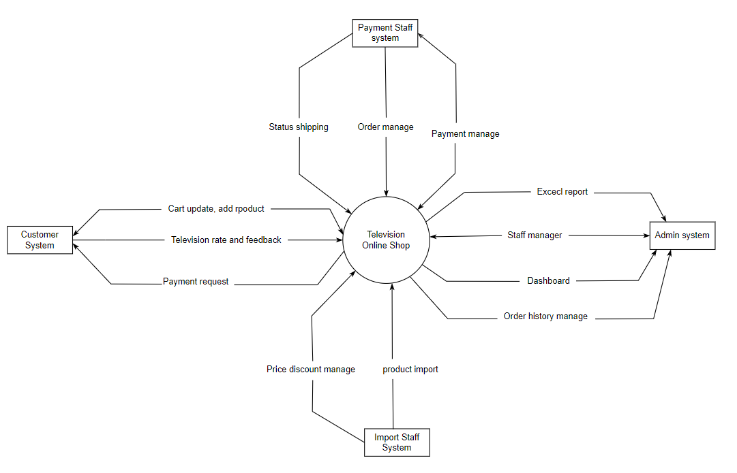

## 2. System Functions

### a. Screen Flow

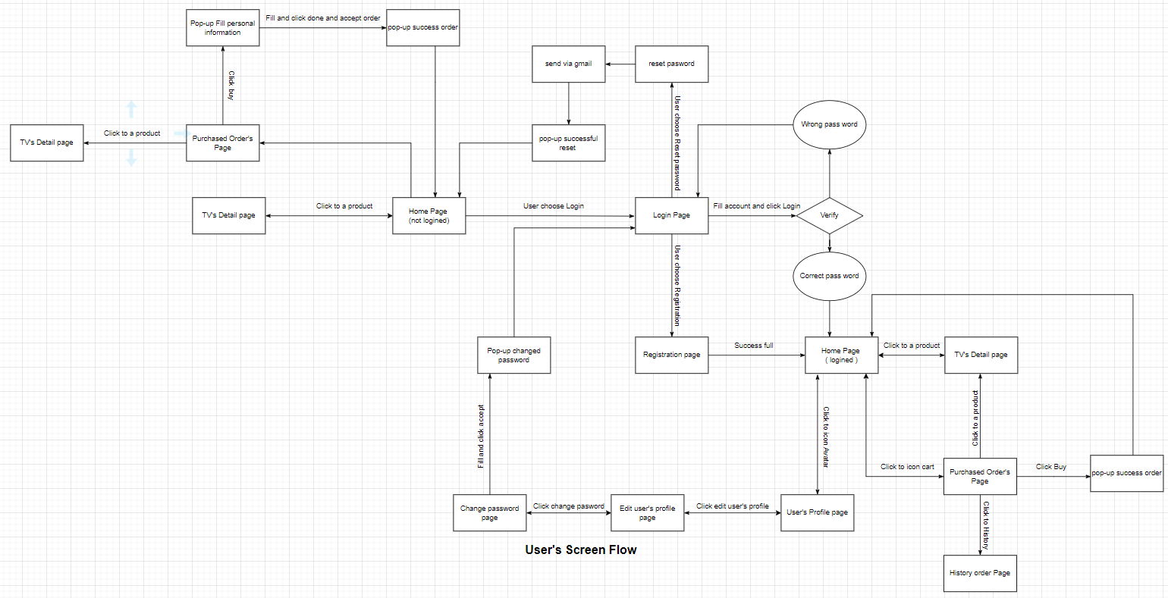

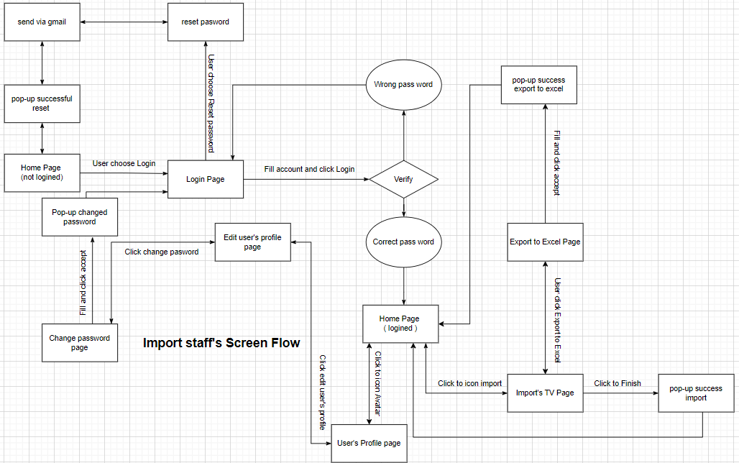

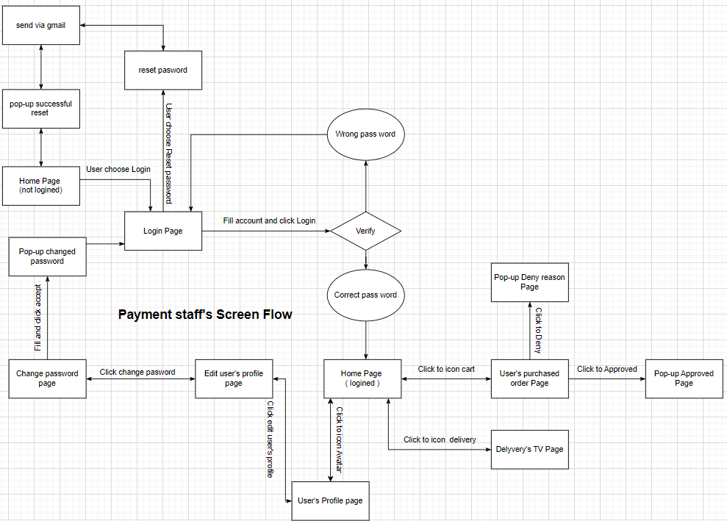

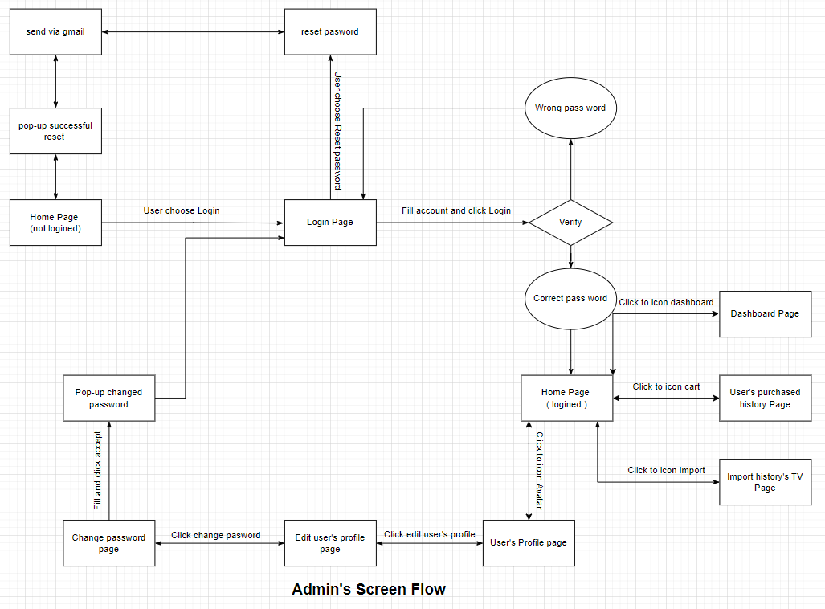

### b. Screen Details

|  |  |  |  |
| --- | --- | --- | --- |
| **No** | **Feature** | **Screen** | **Description** |
| 1 | Common | Home Page | View, Search TV by type, price, etc. |
| 2 | Common | Login | User enter username, password and able to reset password. |
| 3 | Common | Register | User register account. |
| 4 | Admin | Dashboard | View weekly, monthly, quarterly, yearly statistics. |
| 5 | Admin | User's purchased history Page | View user’s purchased history list. |
| 6 | Admin | Import history’s Page | View import’s history list. |
| 7 | Payment staff | User’s purchased order Page | View, change status (deny, approved). |
| 8 | Payment staff | Delivery’s TV Page | View and change status delivery (pending, shipping, success ). |
| 9 | Import staff | Import’s TV Page | View, change status import’s TV list (Finish, not finish). |
| 10 | Import staff | Export to Excel Page | Export import list to Excel. |
| 11 | Common | Reset Password | Get account when forgetting the password. |
| 12 | Common | User profile | Information of user. |
| 13 | Common | Change password | Change password. |
| 14 | Common | Purchased Order’s Page | View, Edit, Buy list of chose TV. |
| 15 | Common | TV’s Detail Page | View detail of a TV and add to cart. |
| 16 | User | History Order Page | View lost of bought TV. |
| 17 | Common | Edit profile | View, edit personal profile. |

### c. User Authorization

|  |  |  |  |  |
| --- | --- | --- | --- | --- |
| **Screen** | **Admin** | **User** | **Import staff** | **Payment staff** |
| Dashboard | x |  |  |  |
| Login |  |  |  |  |
| * Login | X | X | X | X |
| * Reset Password | X | X | X | X |
| * Register |  | X |  |  |
| User's purchased history Page | X |  |  |  |
| Import history’s Page | X |  |  |  |
| Delivery’s TV Page |  |  |  | X |
| User’s purchased order Page |  |  |  | X |
| Import’s TV Page |  |  | X |  |
| Export to Excel Page |  |  | X |  |
| User profile | X | X | X | X |
| Subject Setting Detail | X | X |  |  |
| Change password | X | X | X | X |
| Purchased Order’s Page | X | X | X | X |
| TV’s Detail Page | X | X | X | X |
| History Order Page |  | X |  |  |
| Edit profile | X | X | X | X |

In which:

* Role1: Admin who can view statistic and manage staff, user. Manage of TV shop.
* Role2: User who can able login, View TV products and order TV.
* Role3: Import staff who can control importing TV and can be export list of import TV to excel.
* Role4: Payment staff who can confirm order update shipping status, edit payment status.

### d. Non-Screen Functions

|  |  |  |  |
| --- | --- | --- | --- |
| **Id** | **Feature** | **System Function** | **Description** |
| 1 | Change password | Update password of account | When users forget their password, they can change it. |
| 2 | Security System | Protection Information | The system protects students and teachers information. |
| 3 | Real time system | Be access all times | The system must be always access all times |

## 3. Entity Relationship Diagram

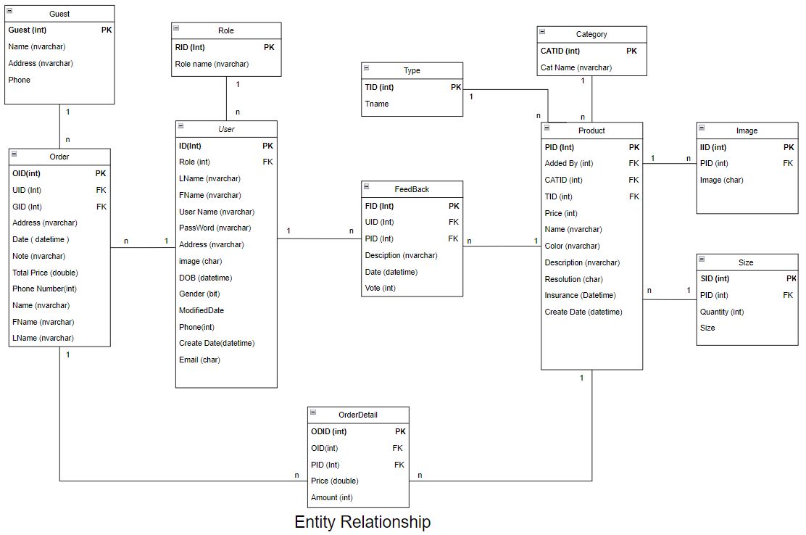

**Entities Description**

|  |  |  |
| --- | --- | --- |
| **#** | **Entity** | **Description** |
| 1 | Product | Store product information. |
| 2 | Image | Store image of product. |
| 3 | Size | Store size and quantity of product. |
| 4 | Type | Store type of product. |
| 5 | Category | Store category of product. |
| 6 | User | Store user information. |
| 7 | Role | Store role of user. |
| 8 | Order | Store order of user and guest. |
| 9 | OrderDetail | Store detail price of single product in a order . |
| 10 | FeedBack | Store detail a Feedback of user about a product. |
| 11 | Guest | Store guest information. |

# II. Functional Requirements

## 1. Login and Sign up

### a.Login

### 

When the user click to Login/Sign up on upper the right of the website they will direct to the login page. They can have the choice to log in or sign up for a new account. If they login successfully, the system will move them directly to the home page for roles. If login fails, they will have to report for login failure and come back to the login page. While the system takes the data of user insert to login, it will check if the account exists or not.

### b. Login with Google Account

### c. Sign up

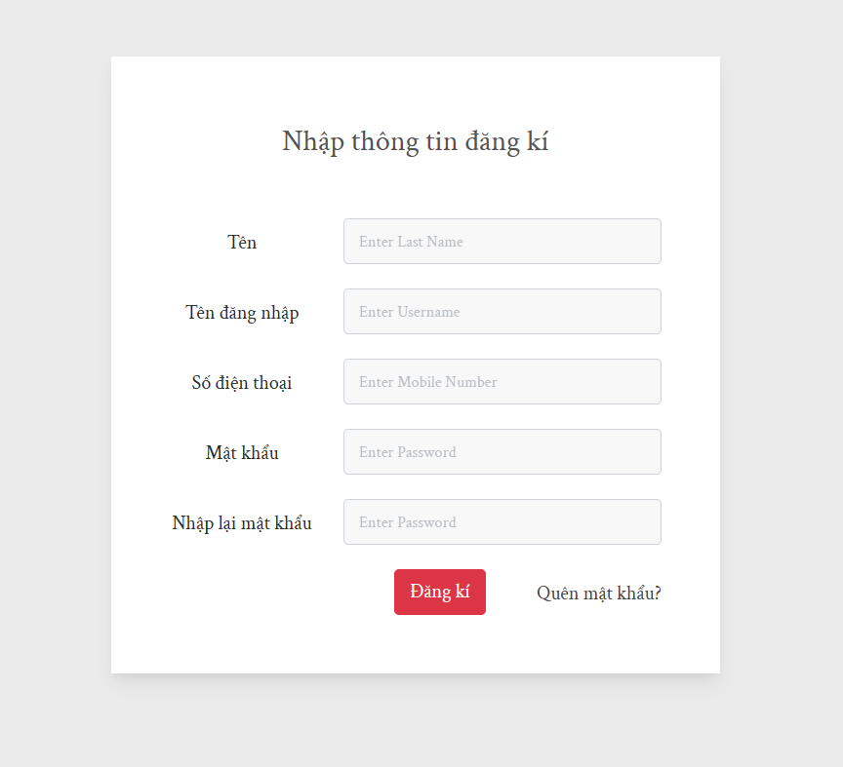

When the user clicks on register on login’s page or register on other ‘s page they will direct to the register page. Page will request to fill the form such that when click on submit button. If all the input text formats the conditions. Page will accept users to create the new account. The data will be added to the database and the page will auto login and respond to the Home page.

## 2. Home

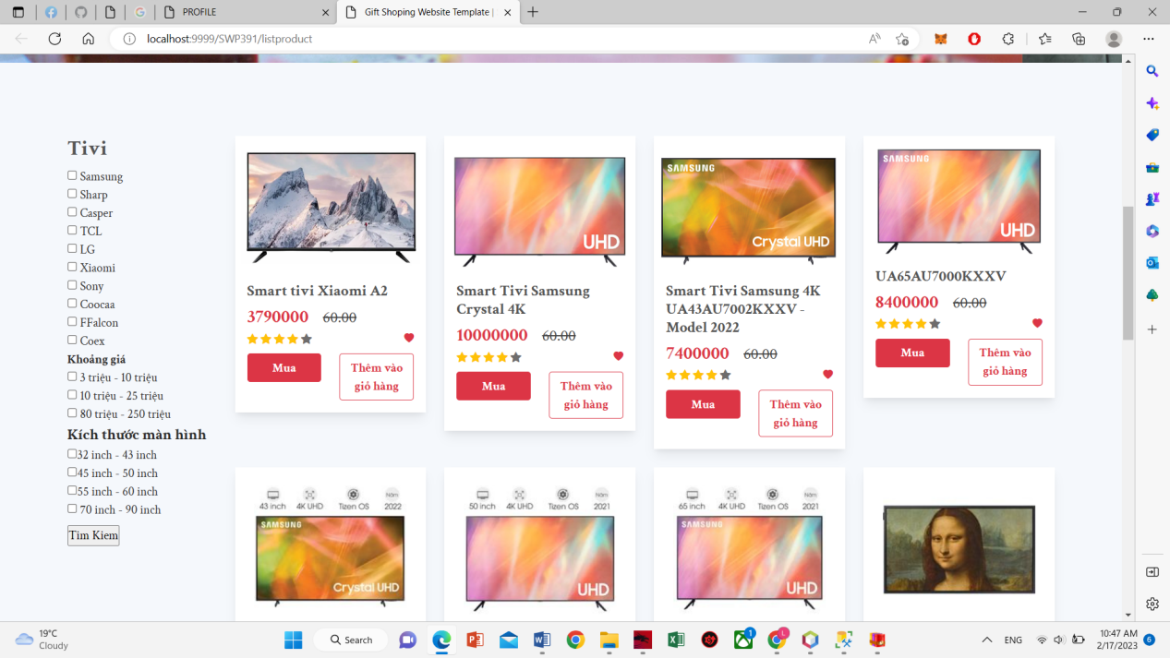

When users are on the home page, they can see the newest TV products. They can search and select to view the details of each product and then add it to the cart.

## TV detail

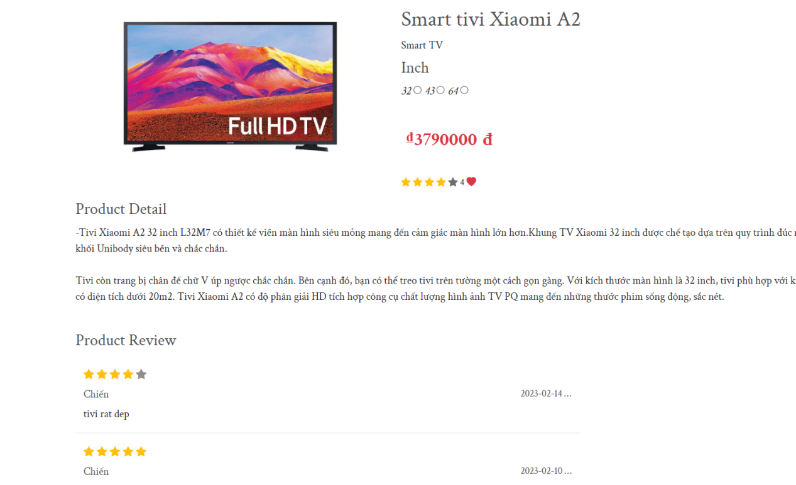When the user selects each product on the home screen or search, it will go directly to the product detail page. This page allows users to view detailed product information such as color, resolution, insurance, etc.

## User profile

## 

Users can view their profile by clicking in the avatar on the top right of the website. They can update their profile like: name, date of birth, gender,... They can also change their password here.

## Password

### Change Password

## 

A screen allow user to change password of his/her own password.

### Forgot Password

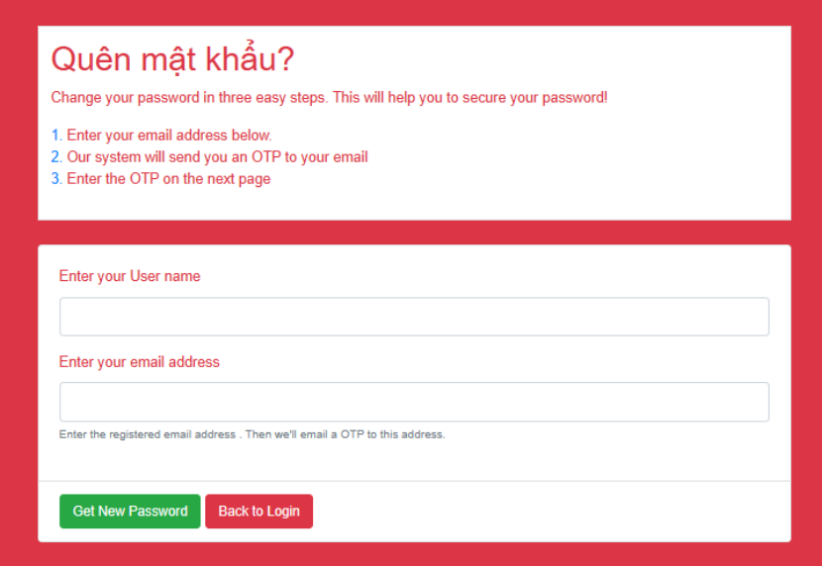

## Manage Account

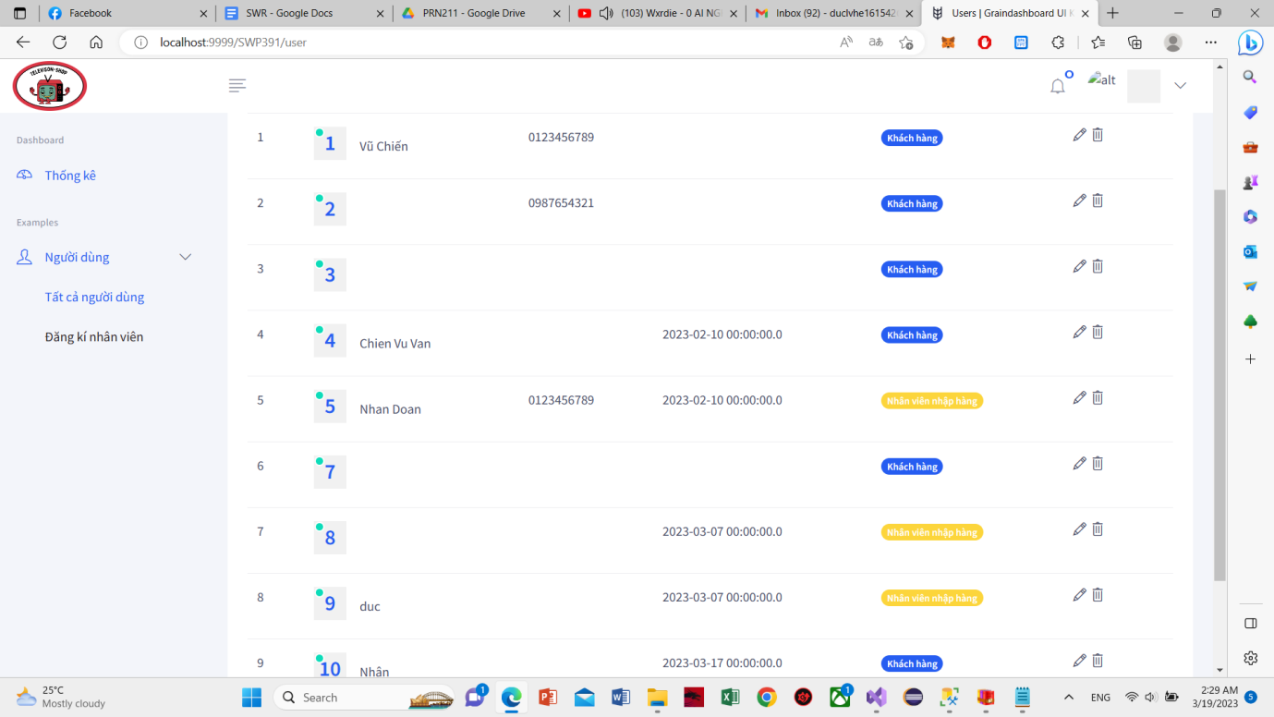

This function allows the actor to view the account list and manage accounts.

## Edit Account

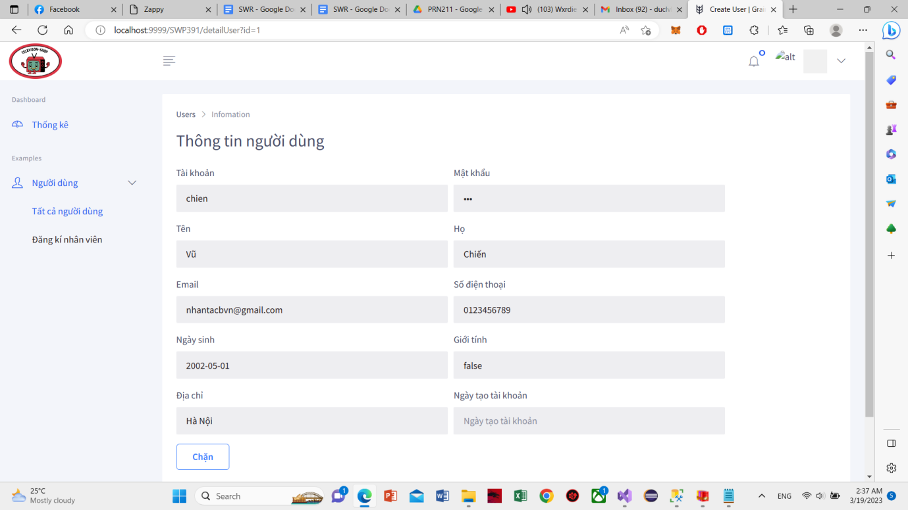

This function allows the actor to edit the information of an account.

## Add Staff Account

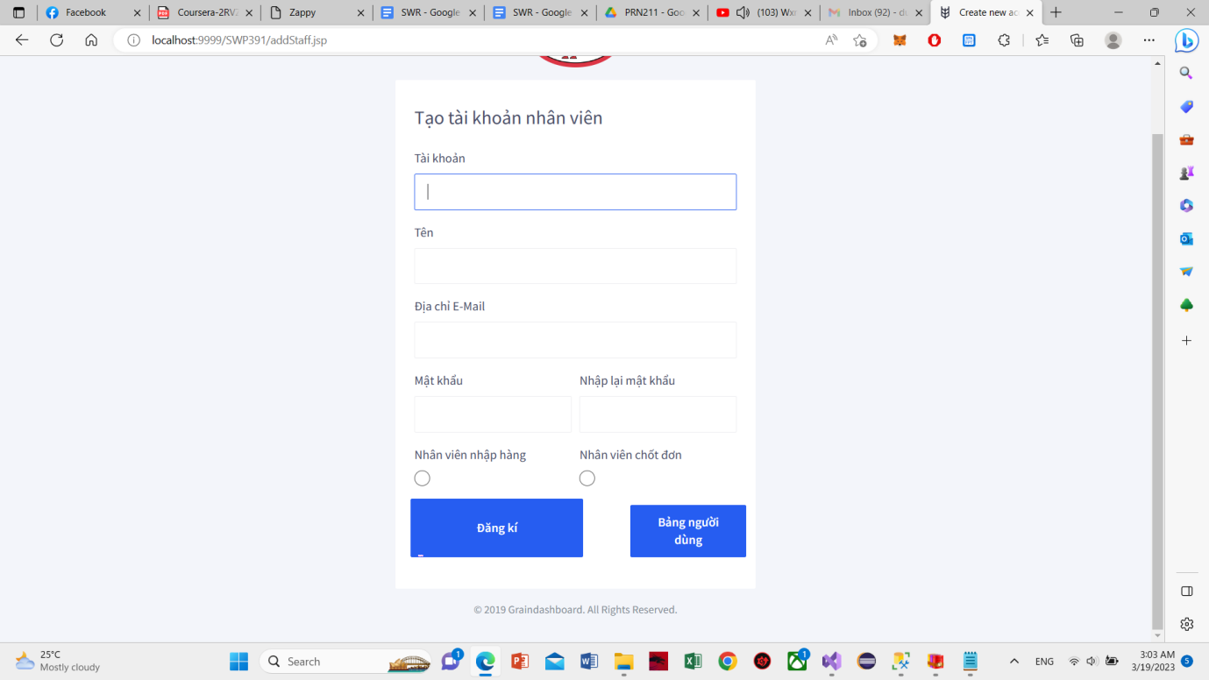

This function allows the actor to add new account staff.

## Delete staff account

This function allows the actor to delete account staff.

## Manage Reveue

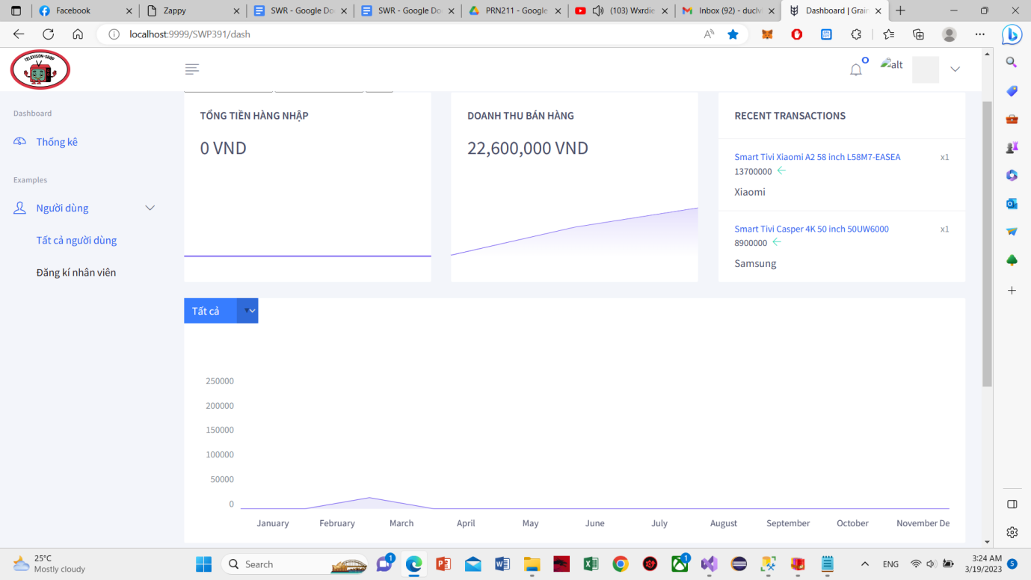

This function allows the actor to view Revue.

## Export order to Excel

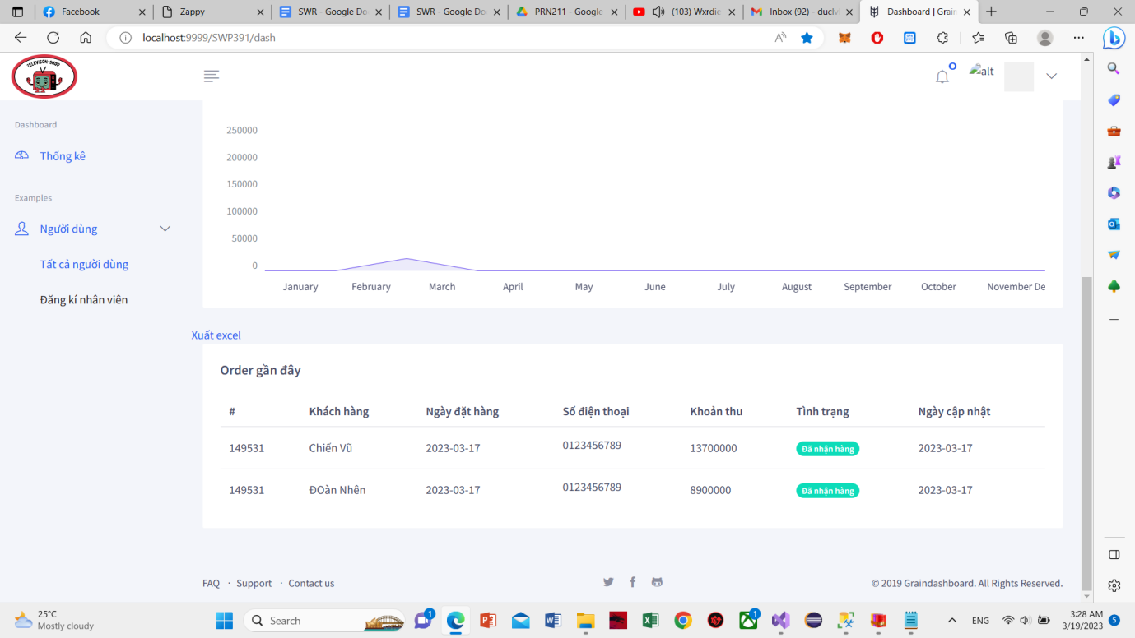

This function allows the actor to export Revue to excel.

## Product manage

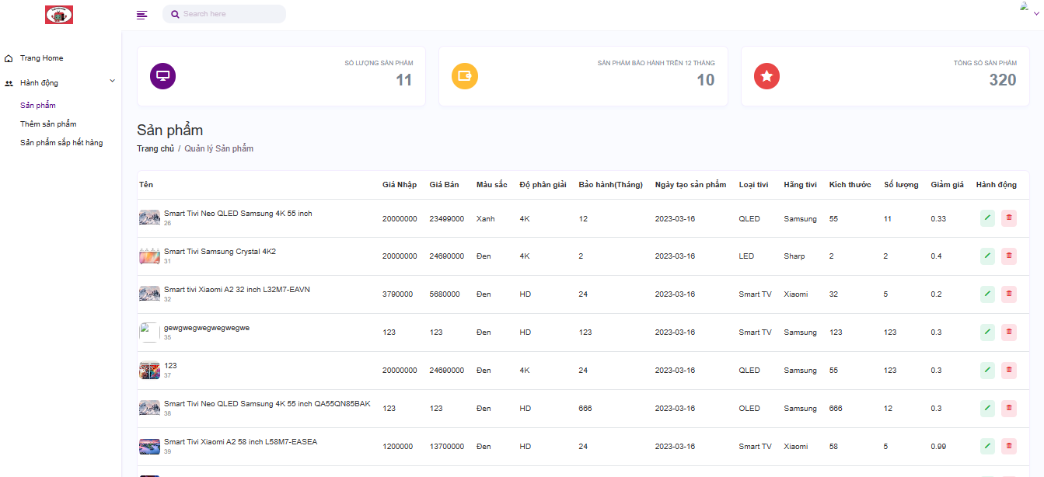

This function allows the actor to view the product list and manage the product.

## Add product

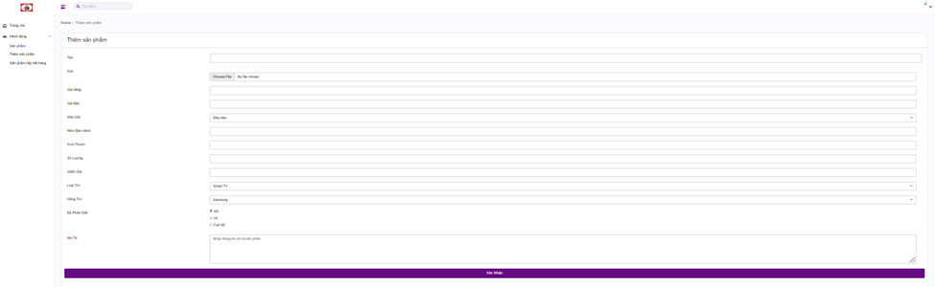

This function allows the actor to add product.

## Edit Product

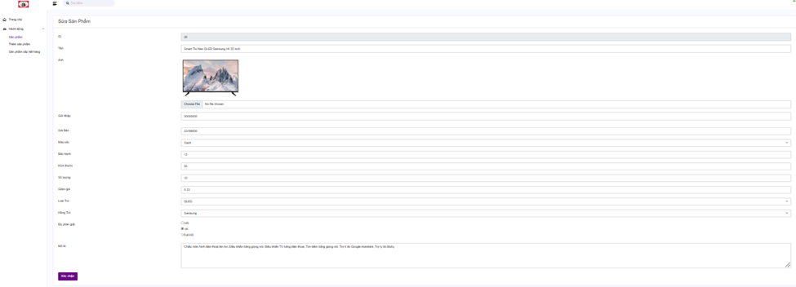

This function allows the actor to Edit product.

## Delete Product

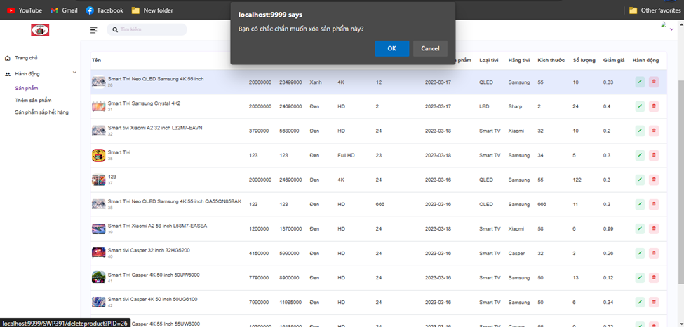

This function allows the actor to delete product.

## Search product

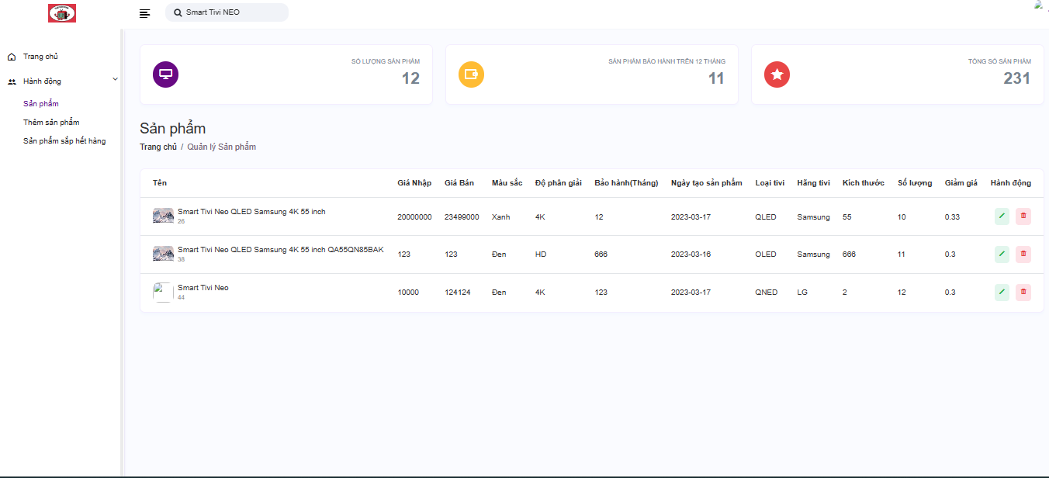

This function allows the actor to search product by name.

## Manage order

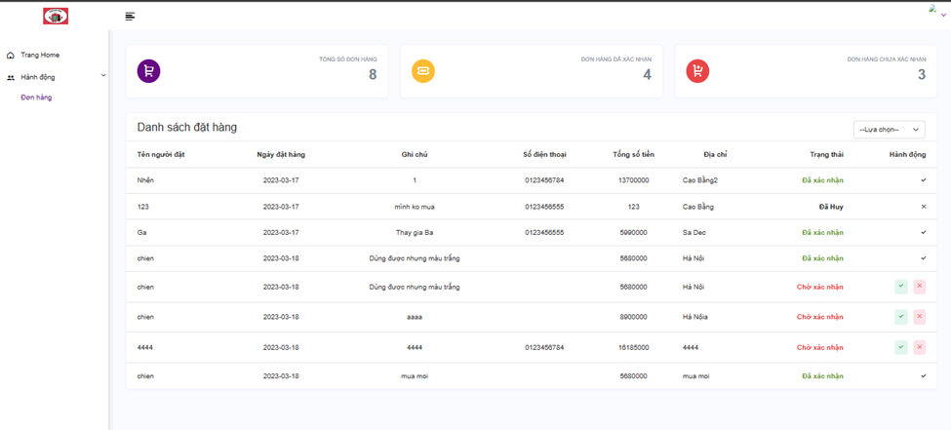

This function allows the actor to view the order list and manage the order.

## Update order

This function allows the actor to view the order list and manage the order.

## Search order

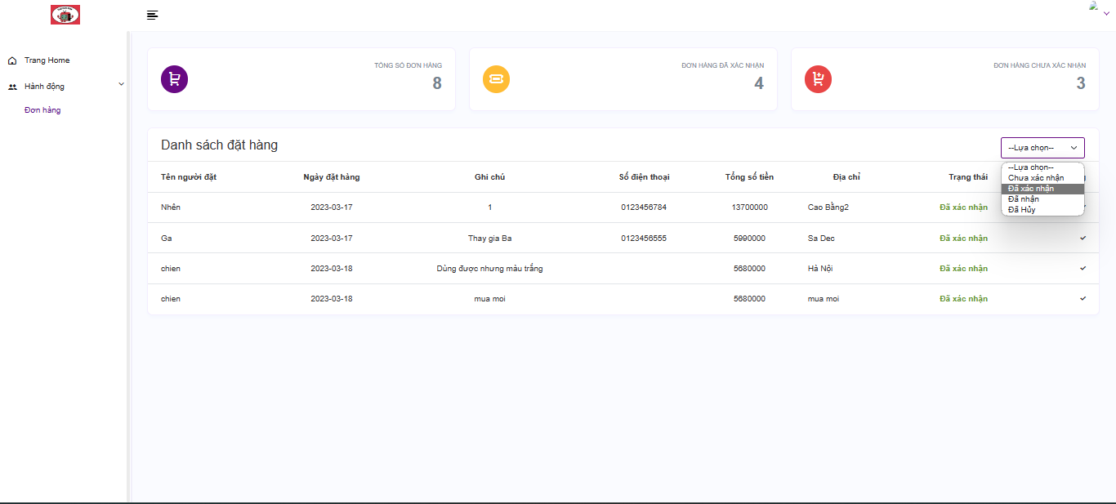

Actor searches questions by selecting keywords by option.

## Add to cart

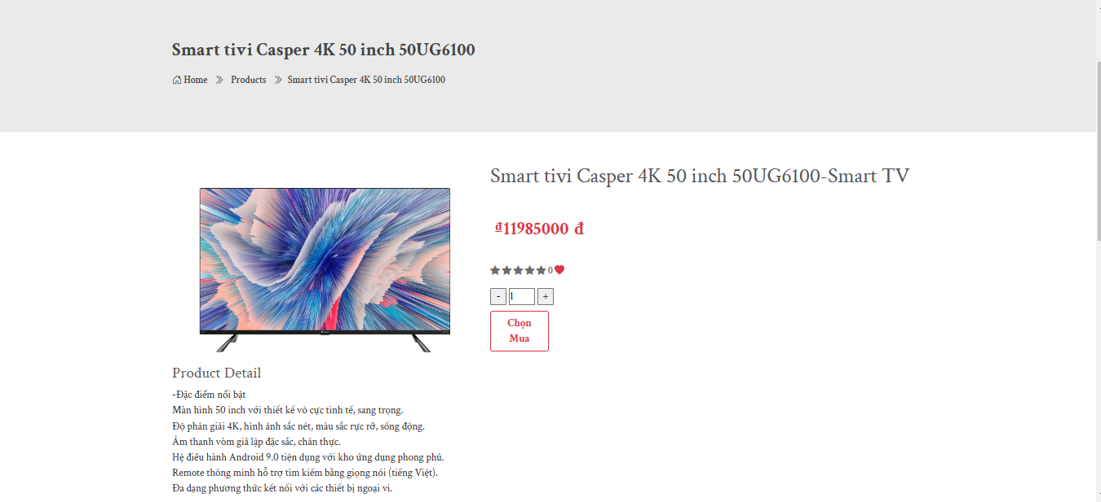

This use case describes the process of adding an item to the shopping cart.

## Edit cart

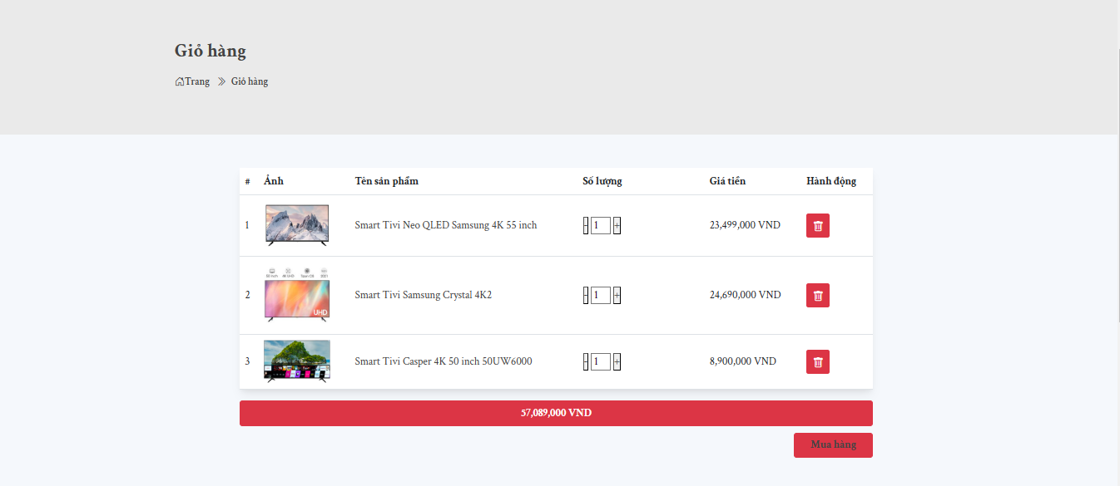

This use case describes the user modifying their shopping cart by adding product quantity or removing product from their cart on the store's website.

## Purchase

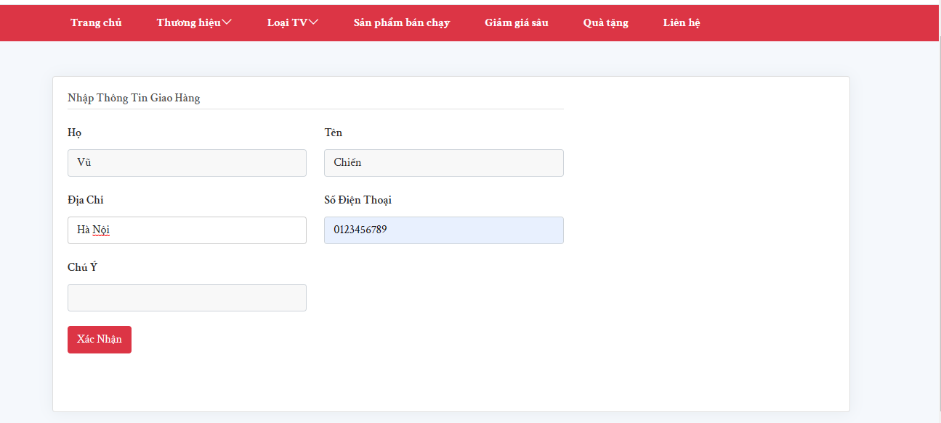

This use case describes the user filling in their personal information such as address, phone number, and name, then confirming their purchase on the website.

## Tracking order

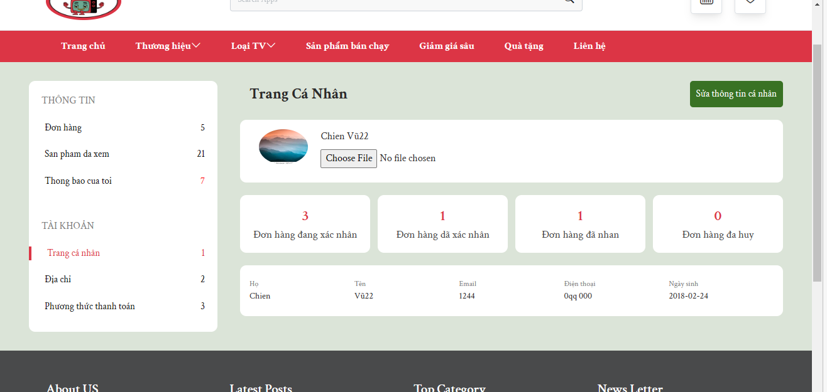

This use case describes the process of tracking placed orders by the customer.